[Optional date]

Dear INSERT CEO NAME,

As employers and service and product providers, corporations are part of our communities. But it is not their role to set public policy, and it does not serve the public good for corporations to get involved in policing. That’s why I was disappointed to learn about your connection to the Atlanta Police Foundation and to the “Cop City” project in Atlanta.

If constructed, Cop City would be one of the largest militarized police training centers in the United States. Plans include military-grade training facilities, a mock city in which to practice urban warfare, and more. Police from all over the country would be trained in repressive tactics frequently turned on communities of color. That includes police exchanges with foreign governments with a history of human rights violations and brutality against civilians.

Cop City would also destroy much of the Weelaunee Forest, Atlanta’s largest green space, warming nearby majority Black neighborhoods by as much as 10 degrees.

Prisons and policing do not keep us safe or prevent violence. They don't help survivors of harm heal. Instead, these institutions undermine human and civil rights, disproportionately targeting and harming African American, LGBTQ, and poor people. Don’t let this be your philanthropic legacy.

As someone who cares deeply about community safety, I urge you to:

--Publicly commit to withholding resources and funding from Cop City.

--End all collaboration with the Atlanta Police Foundation and all other police foundations.

--Invest in the building blocks of true community safety by paying good wages to your workers, paying your fair share of taxes, and adopting sustainable and socially responsible business practices.

A growing number of individual investors, foundations, endowments, pension funds, and corporations are refusing to be complicit in police violence and mass incarceration. Many are eager to work with grassroots organizations to uplift economic growth that is sustainable and just. I urge you to join them.

Sincerely,

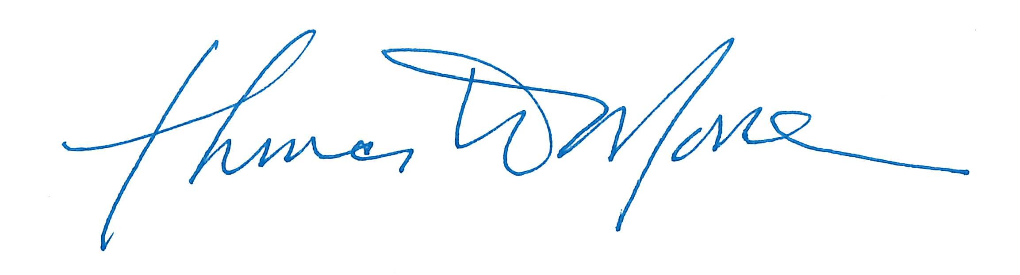

Sample Signatory